**EXPERIMENT NO. 5**

**TO PERFORM EROSION AND DILATION ON A BLACK AND WHITE IMAGE AND ITS APPLICATION FOR BOUNDARY EXTRACTION**

**EXPERIMENT NO. 5: Morphological Processing**

**AIM: -** To perform erosion and dilation on a black and white image and its application for boundary extraction

**THEORY: -**

Once segmentation is complete, morphological operations can be used to remove imperfections in the segmented image and provide information on the form and structure of the image. Morphological image processing (or *morphology*) describes a range of image processing techniques that deal with the shape (or morphology) of features in an image

Morphological operations are typically applied to remove imperfections introduced during segmentation, and so typically operate on bi-level images.

Structuring elements can be any size and make any shape. However, for simplicity we will use rectangular structuring elements with their origin at the middle pixel.

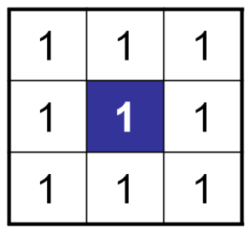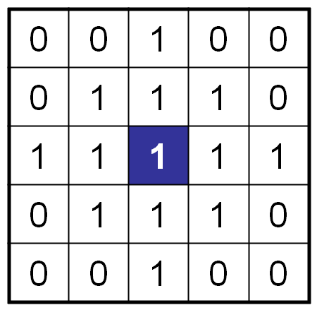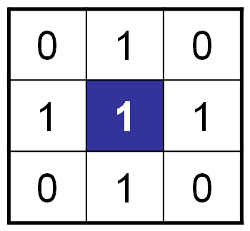

**Morphological Operations**

Fundamentally morphological image processing is very like spatial filtering

The structuring element is moved across every pixel in the original image to give a pixel in a new processed image

The value of this new pixel depends on the operation performed

There are two basic morphological operations: erosion and dilation

**Dilation** of image *f*  by structuring element *s* is given by *f*   *s*

The structuring element s is positioned with its origin at *(x, y)* and the new pixel value is determined using the rule:

**Original Image Processed Image with Dilated Pixels Structuring Element**



**Original image Dilation by 3*3 square Dilation by 5*5 square**

**structuring element structuring element**

**Erosion** Erosion of image *f* by structuring element *s* is given by *f* ⊖ *s*

The structuring element s is positioned with its origin at *(x, y)* and the new pixel value is determined using the rule:

**Compound Operations**

More interesting morphological operations can be performed by performing combinations of erosions and dilations

The most widely used of these *compound operations* are:

* + Opening
  + Closing

**Opening**

The opening of image *f* by structuring element *s,* denoted *f* ○ *s* is simply an erosion followed by a dilation

***f* ○ *s = (f* ⊖*s)***  ***s***

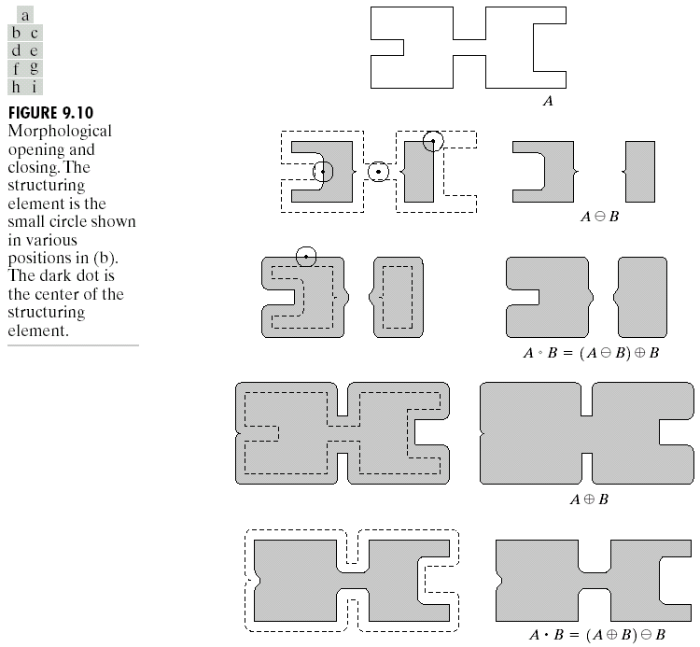

**Original Image Processed Image**

**Closing**

The closing of image f by structuring element s, denoted f • s is simply a dilation followed by an erosion

 f • s = (f s)⊖s

**Boundary Extraction**

Extracting the boundary (or outline) of an object is often extremely useful

The boundary can be given simply as  *β(A) = A – (A⊖B)*

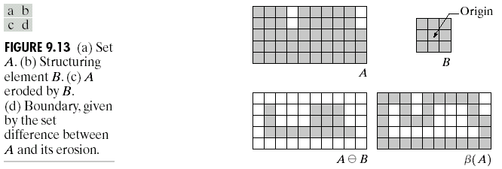

**Hit or Miss Transform**

The hit-and-miss transform is a general binary morphological operation that can be used to look for particular patterns of foreground and background pixels in an image. It is actually the basic operation of binary morphology since almost all the other binary morphological operators can be derived from it. As with other binary morphological operators it takes as input a [binary image](http://homepages.inf.ed.ac.uk/rbf/HIPR2/binimage.htm) and a [structuring element](http://homepages.inf.ed.ac.uk/rbf/HIPR2/strctel.htm), and produces another binary image as output.

[structuring element](http://homepages.inf.ed.ac.uk/rbf/HIPR2/strctel.htm)s

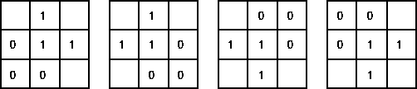

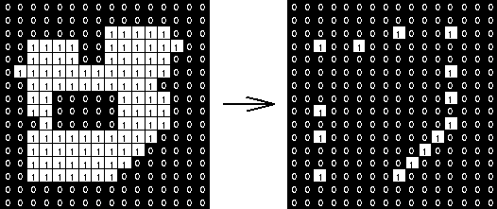

**PROGRAM:**

*// Erosion and dilation*

*//118A2044 Dikshita Kambri*

clc;

clear all;

im = imread("C:\Users\hp\Documents\Image Processing-Scilab\Images\blobs.png");

b=[1 1 1;1 1 1;1 1 1];

[r c]=size(im)

e=zeros(r,c)

d=zeros(r,c)

o=zeros(r,c)

cl=zeros(r,c)

a=find(b==1)

count=length(a);

boundary=zeros(r,c);

for i=2:r-1

for j=2:c-1

t=im(i-1:i+1,j-1:j+1)

x=sum(t.*b)

if x==count

e(i,j)=1

d(i,j)=1

elseif x>=1

e(i,j)=0

d(i,j)=1

else

e(i,j)=0

d(i,j)=0

end

end

end

figure(1)

subplot(1,2,1)

title('original')

imshow(uint8(255*im));

subplot(1,2,2)

title('erosion')

imshow(uint8(255*e));

figure(2)

subplot(1,2,1)

title('original')

imshow(uint8(255*im));

subplot(1,2,2)

title('dilation')

imshow(uint8(255*d));

figure(3)

subplot(1,2,1)

title('original')

imshow(uint8(255*im));

subplot(1,2,2)

title('Boundary Extracted')

imshow(uint8(255*boundary));

*//opening*

for i=2:r-1

for j=2:c-1

t=e(i-1:i+1,j-1:j+1)

x=sum(t.*b)

if x>=1

o(i,j)=1

else

o(i,j)=0

end

end

end

*//closing*

for i=2:r-1

for j=2:c-1

t=d(i-1:i+1,j-1:j+1)

x=sum(t.*b)

if x==count

cl(i,j)=1

else

cl(i,j)=0

end

end

end

figure(4)

subplot(1,2,1)

title('opening')

imshow(uint8(255*o));

subplot(1,2,2)

title('closing')

imshow(uint8(255*cl));

**OUTPUT**:

1)Erosion:

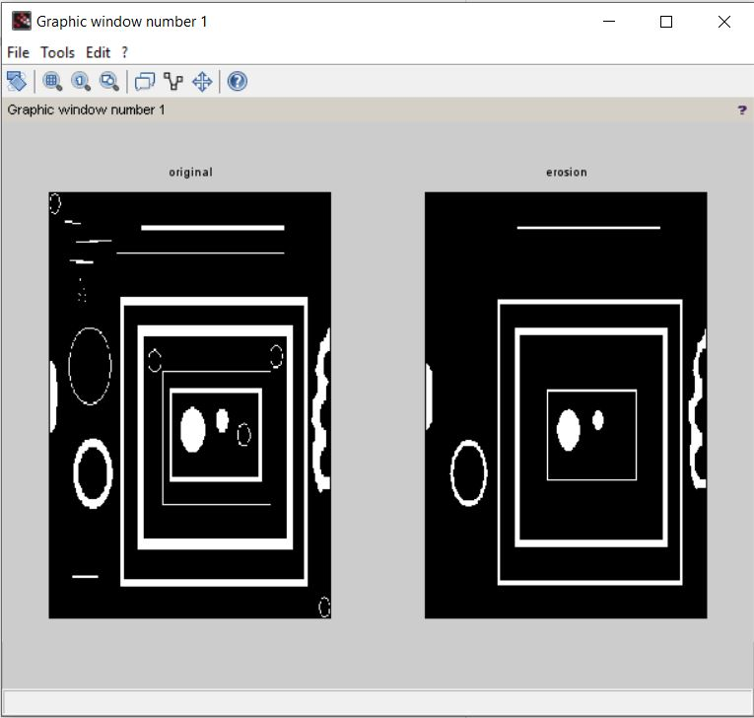

**2) Dilation:**

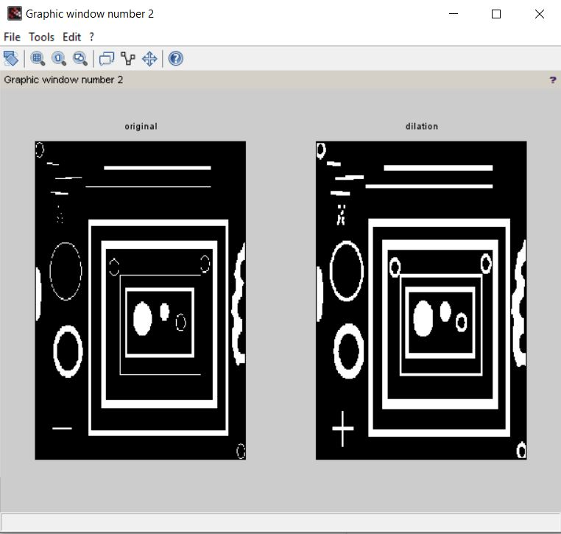

**3) Boundary-Extracted:**

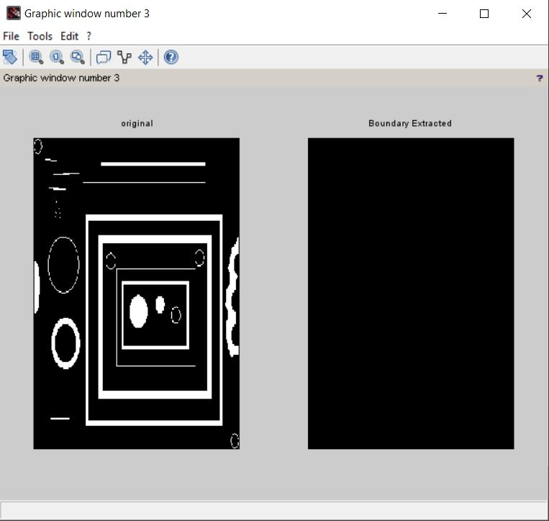

**4) Closing and Opeing:**

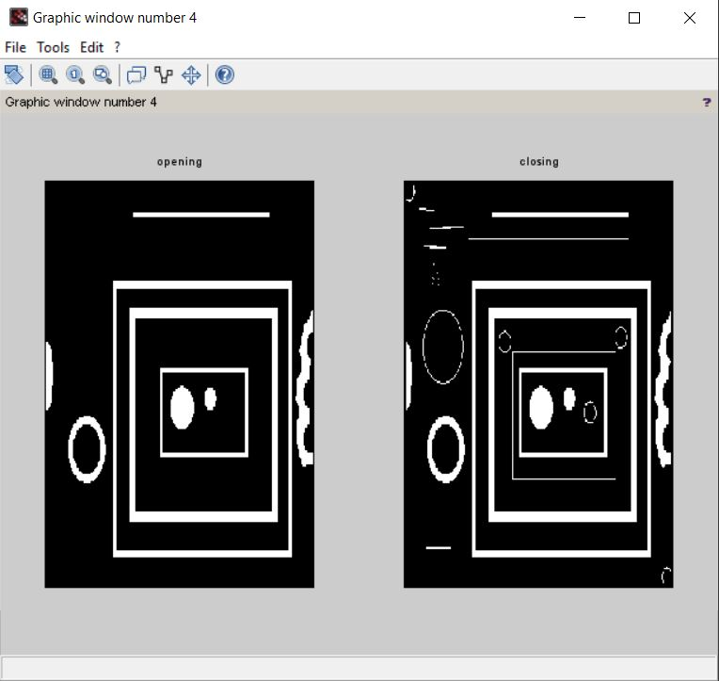

**CONCLUSION**:

We studied that dilation increases size of the object while erosion decreases the size of the object. Further we observed that dilation fills the holes and broken areas, while erosion removes small anomalies.